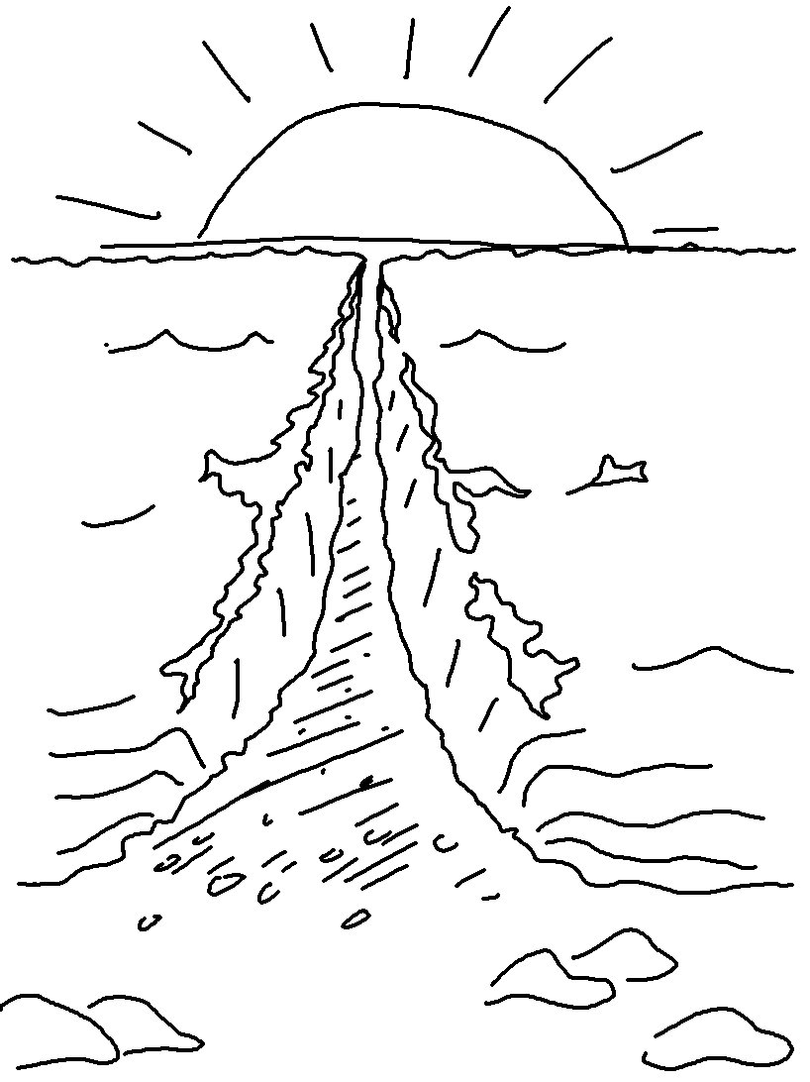
He kept them _ _ _ _ so they were
not _ _ _ _ _ _. Psalms 78:53_{NLT}

